MMPROJ1
Design Document

General Directions:

When preparing and writing your documentation and research paper, please take note of the following:

- Your documentation/ research is an academic paper, always use proper and formal language. Avoid use of slang and colloquialisms. Write your paper in complete English with due attention to spelling, syntax, grammar and context – if necessary, seek proofreading assistance or services.

- Always refer to yourself in the third person, hence: The student must always refer to him/herself as “the proponent” when referring to him/herself in the research paper and all documents related to the MMPROJ project.

- Standard margins are 1” on all sides except for the left margin at 1.5” to allow space for binding.

- Always use 12pts. Times New Roman or Arial font with double spacing. Paragraphs are also double-spaced, not quadruple-spaced.

- All sources must be cited as prescribed by the MLA Style. In-text citations are made by parenthetical citation in the format (Author, Year: page/s); format for the bibliography or “works cited” section can be accessed online (http://www.liu.edu/cwis/cwp/library/workshop/citmla.php).

- Discussions must be clear and concise – make your points brief but substantial.

- All images, sketches, screen shots and the like must be labeled via captions describing or naming the image; any non-original images used as pegs, samples or design must also be cited in the caption.

- ALWAYS bring all your PROJ materials with you from previous PROJ classes. This will streamline project workflow and help you strategically as you move along the Multimedia Project Series.

- The Guide proper is divided into three major sections depending on the document due at certain MMPROJ subjects, when compiled in its entirety; this whole document will be submitted as part of the MMPROJ2 Panel Defense Requirements.

TITLE PAGE (not to be included in MMPROJ2 compilation)
- Contains:
  - DESIGN DOCUMENT in clear text
  - Project Title
  - Proponents’ Name
  - Month/ Year of submission

<Page break>

PROJECT OVERVIEW
- Contains Project Description
- Brief discussion of what the project is and what it’s intended to achieve
- Short and to the point

DESIGN OVERVIEW
- Describes the direction in which the design of the project will go
- Describes considerations the proponent will be conscious of when producing the project. This may include audience preferences, cultural considerations, age, marketability and many other factors
- May include a design philosophy especially if this is a requirement of, or directly related to, the theoretical or conceptual framework of the project.

PRODUCTION PEGS (please use the PRODUCTION PEG FORMAT)
- An existing work upon which you are basing (or derive inspiration for) specific elements of your project (i.e. typeface, layout, story line, color scheme, etc.)
- FIRST discuss briefly what the peg is
- SECOND discuss what element of the peg you are pegging your project on and why
- THIRD discuss how you will adapt or incorporate the existing peg into your design
- Use the specified form for guidance (available in the MMPROJ e-group files)
- You may use any layout or description style that would best match the particular peg you are working on
- Guide Questions:
  - What is it about this existing work that I wish to use in my project?
  - Why will this benefit my project?
  - How will I adapt this peg to my project so that it is original and my own?
  - Is this the only work of its kind that I am pegging on? What other works are there and how are they similar/ different?

DESIGN STUDIES
- Will be developed as the production proceeds
- May contain as many or as little studies as required by the adviser; for online/ electronic studies (i.e. web layouts, etc.) low-res printouts may suffice as long as the design development process is documented
- Page break after every design set
- Includes, but is not limited to:
  - Layout thumbnails
  - Color schemes
  - Character studies/ turnarounds
  - Costume studies/ options

DESIGN GUIDE
- Developed after approval of studies and determination of final approved design
- Describes the considerations and aspects of the approved design
- Includes “instructions” and “specifications” for the production of the project
- Design Guide will include, among others:
  - Color/ color scheme/ PANTONE or RGB settings
  - Layout/ font/ text guide
  - Logo guide
  - Technical limits (e.g. file sizes, screen sizes)
  - Other items specific to different media (e.g. lighting guide, print sizes, audio levels, etc.)

PRODUCTION MATERIALS (if applicable)
- Compilation of materials/ instruments/ protocols used in the development of the project
- Includes, but not limited to:
  - Surveys
  - Data sheets
  - Experimentation protocols
  - Production notes
  - Content evaluation form

PRODUCTION TIMETABLE
- Should be realistic yet take into consideration that allowances should be made for delays and unforeseen circumstances
- A 2-term timetable does not guarantee that you will pass MMPROJ1 or that you will qualify for enrollment during MMPROJ2
- Gantt Chart of projected workflow timetable from MMPROJ1 to MMPROJ2
- Includes an outlined breakdown of start- and stop-dates for specific stages and elements of the project; also indicates actual start/ stop times for reference
- Sample:
TaskSched StartActual StartSched FinishActual FinishColor pages 3-5June 7June 8June 9June 9

CONSULTATION FORMS (Due during finals presentation)
- Compiled during consultations on production with adviser
- Use the specified form (available in MMPROJ files section)

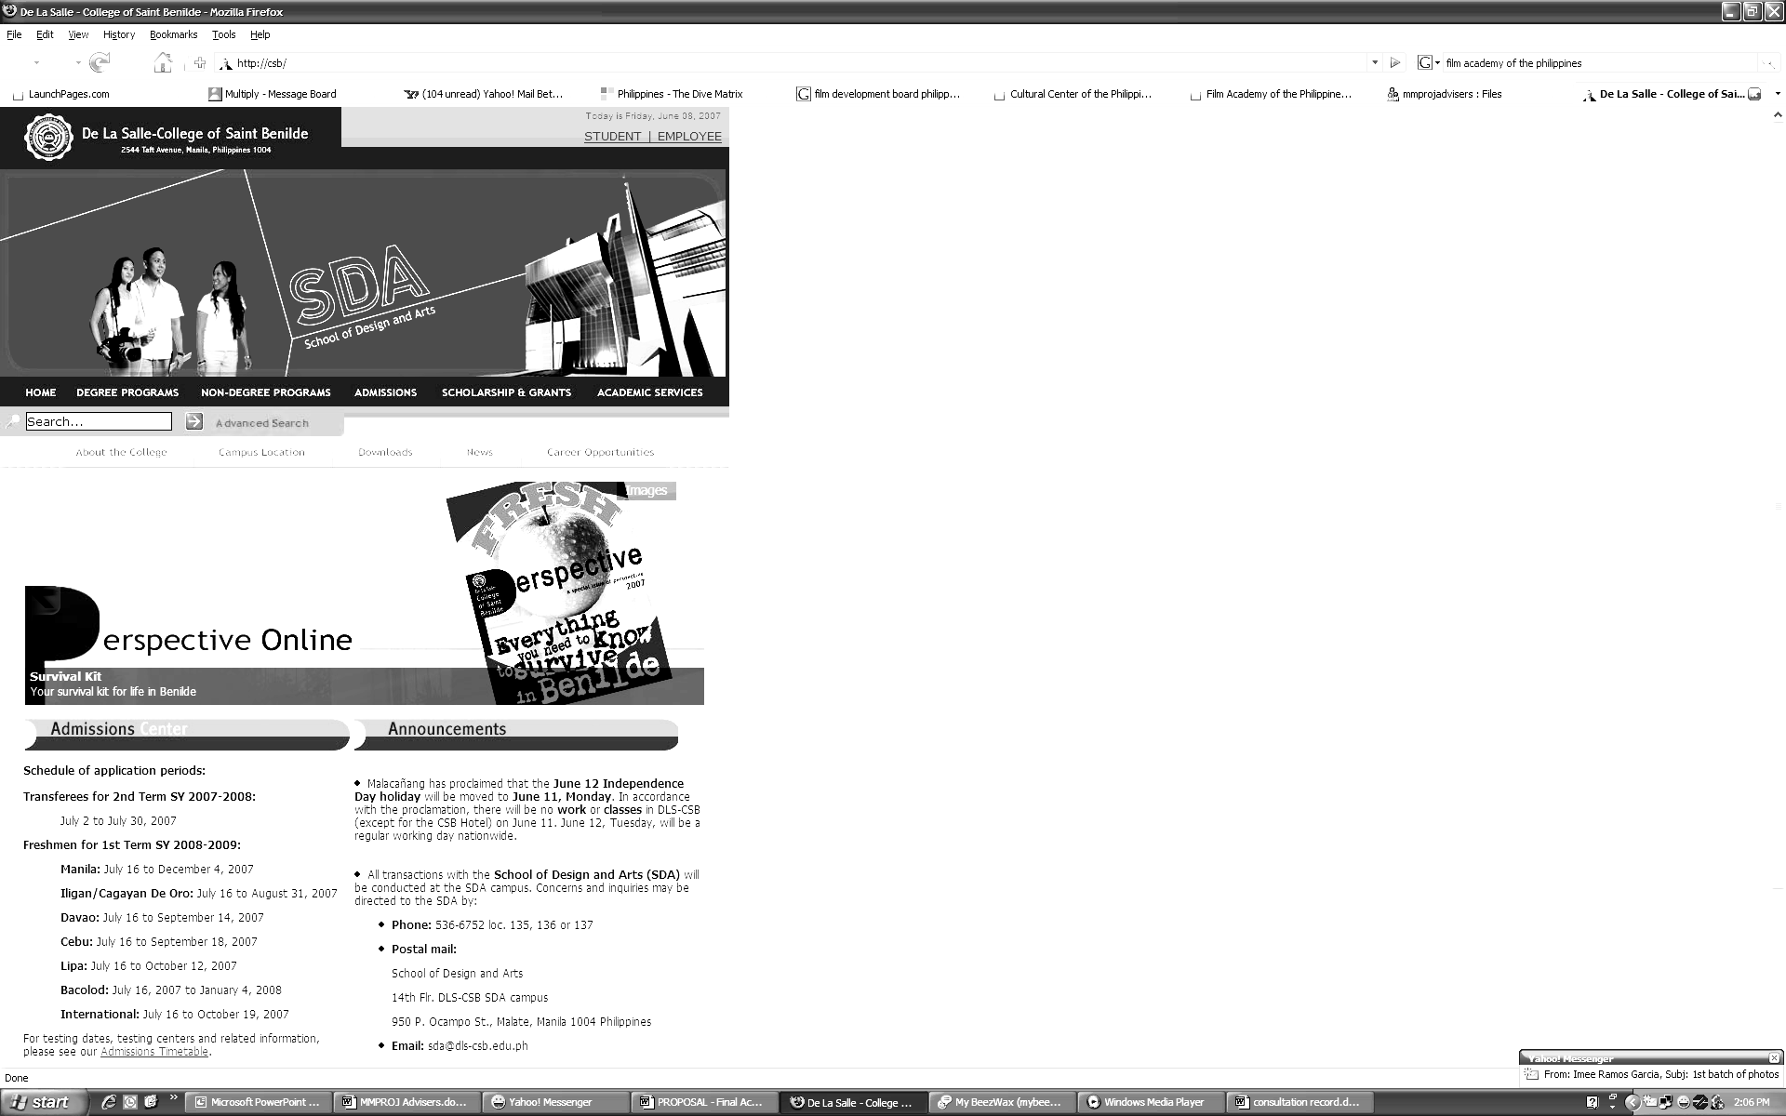

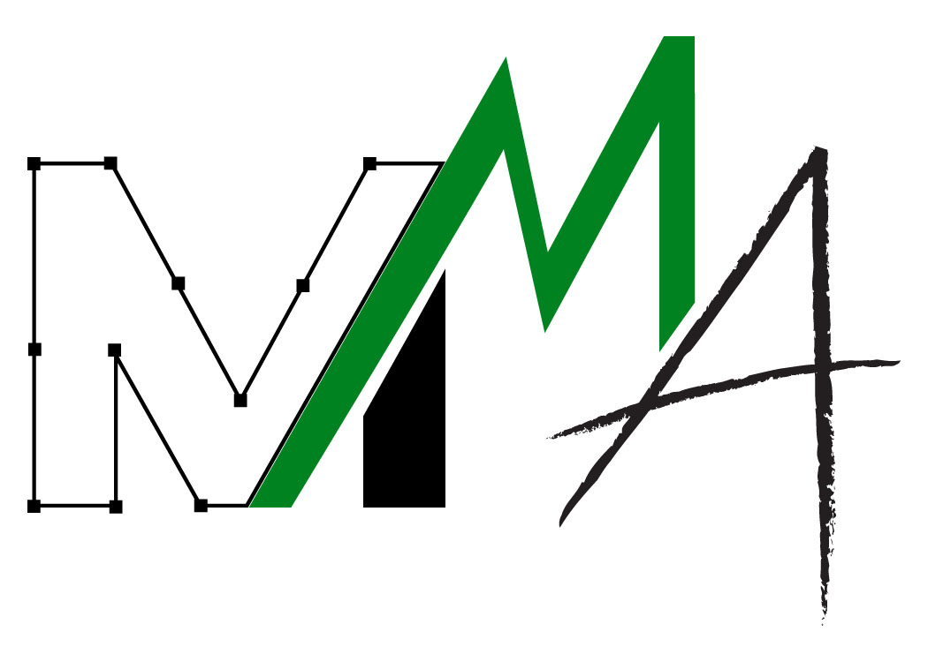
De La Salle–College of Saint Benilde
School of Design and Arts
Multimedia Arts Program

MMPROJ1 PRODUCTION PEG

PEG INFORMATION

Attach screen shots of peg here
* add picture as sample

Title/ Name : | Creator/ Author/ Copyright Owner : | Source :

>> PEG DESCRIPTION

>> DISCUSS THE SPECIFIC ELEMENT YOU ARE PEGGING

>> RELATION OF THE PEG TO YOUR PROJECT/ HOW IS THIS PEG A REFERENCE TO A PARTICULAR ELEMENT OF YOUR PROJECT ?

